Ellen Hill – CPSC 224 – Homework 3: Zag Farkle Full Game & Multiplayer
The intent of this project was to build upon our work from the first homework and second homework, and implement hot seat multiplayer. We also added the Full house combo, a play to total points, and a round by round score board. This was my first time working with classes in Java, and I was very happy to find out that there is no importing- as long as the files are in the same directory, the classes are linked.
I am developing my coding style to start by breaking things up into methods and then implementing them as I go rather than writing them all in main. In a similar fashion, I think I will enjoy using classes much more now that I know they do not need to be packaged like in C++. I went about implementing full house first and it gave me quite a bit of trouble for the edge cases where the hands were primarily 5s and 1s, but I was able to get that figured out. I then went on to implementing the players classes and working on the multiplayer and point cap limitations.
We still have not discussed implementing tests in class. We spoke very briefly about the methodology of testing and what a unit test might look like, but not how to implement them into our code. Jon suggested on my last assignment that I make a Test.java file to store all of my tests, but I still haven’t the foggiest for what I would put in that file. What I will say, is that when I was working on the full house, I wrote in 3 hard coded hands that were different mixes of 5s and 1s to test which one was getting priority in the full house. It was a pain to go back and switch each one, but it was the best I had.
I only used two classes and compartmentalized the rest of my code into methods in Farkle.java, and kept the players in Players.java. I chose to represent them with aggregation because just because the player is not actively playing the game does not mean that they may have played in the past or are not still around.
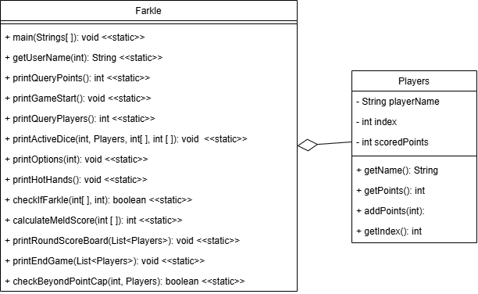

At this time we also have not learned UML Sequence diagrams, only state machine diagrams. She embarrassed a kid in class who tried to use a Sequence diagram in their presentation when we hadn’t learned them in class, so I’ve put a small snippet of the State Machine Diagram for Farkle here, in hopes that this passes since we haven’t learned them yet. Both of the diagrams are drawn with draw.io!
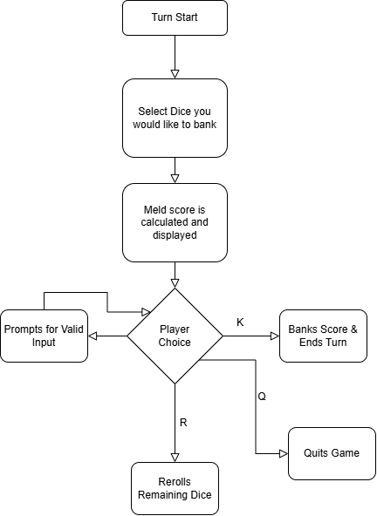

I really struggled with adding the fullhouse code just because of the edge cases, and wrapping up a nice clean farkle “end game” is much harder than it looks. I ended up writing this document before I took one more attempt at the “end game” so it is working in my submission, know I was successful. If I had more time, I probably would have played around with classes more since they were new to me and cleaned up main more. I would have liked to make a testing page so I didn’t have to manually make all the hands to test my edge cases.

Appendix:
Intro Screen:
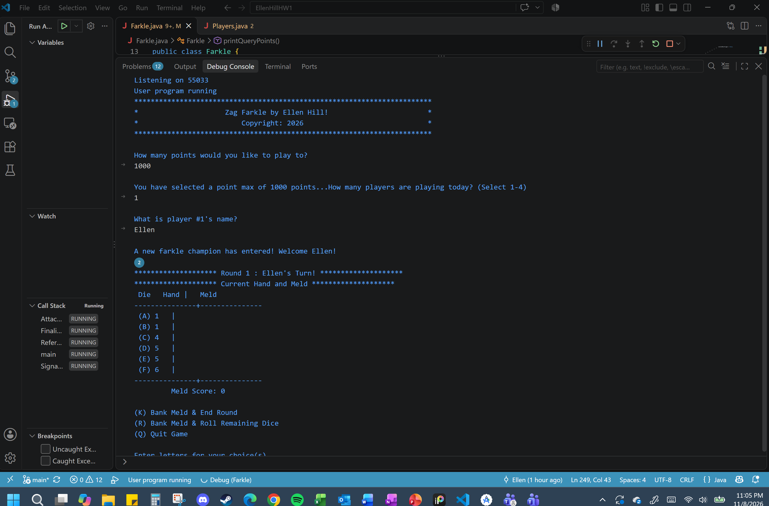
End of Game:
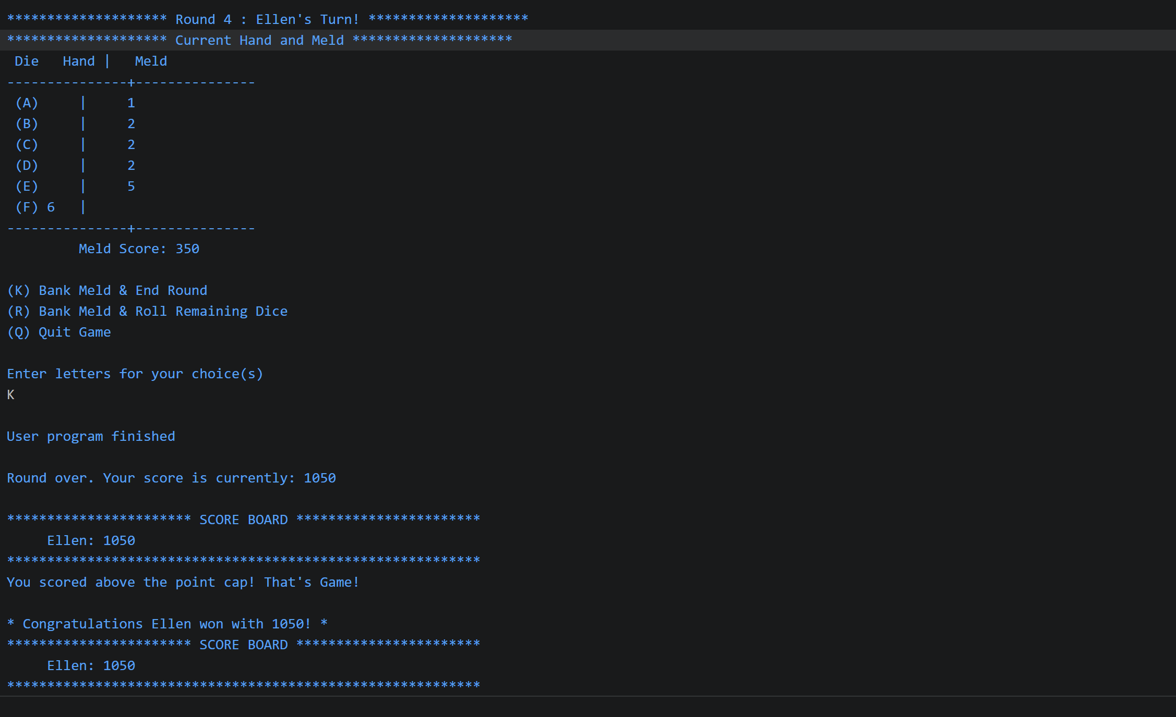

Luckiest FullHouse that was also a hot hands:
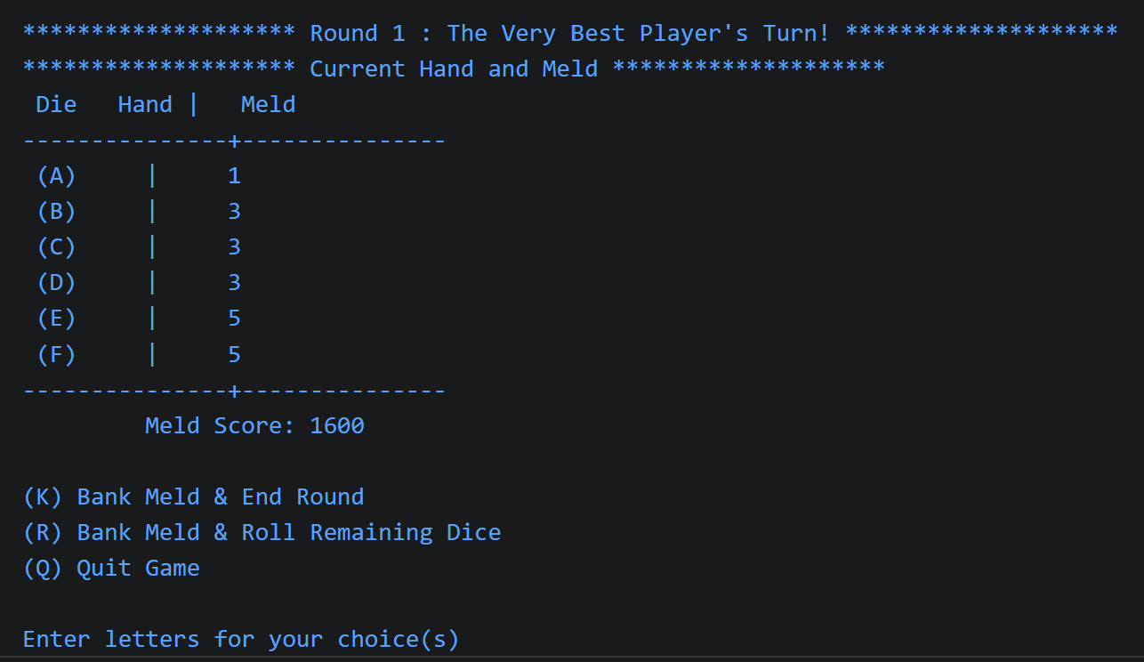
Hitting Enter 3 Times:
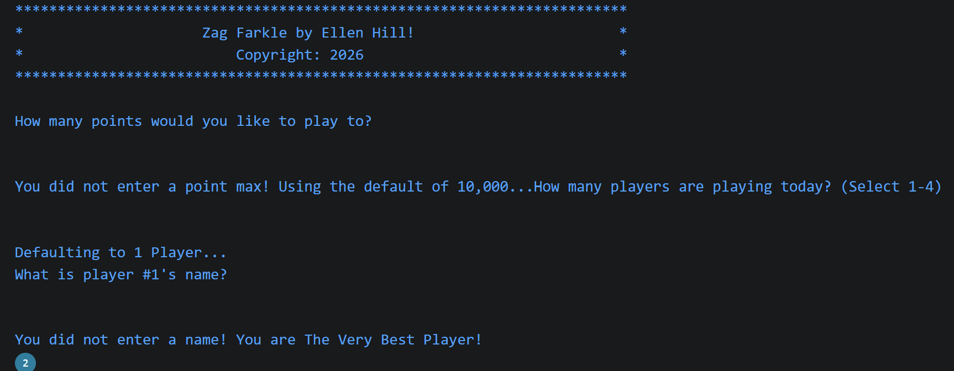
Custom Naming:


